Analysis of Variability in Hospital Charges Across the United States

Bill White, Bosco Sitati, Ji-Heon Kim, Leishla Perez

The overall aim of this project was to determine if there exists a correlation between the amounts charged by a hospital for a procedure and the median income of the regional area the hospital is located. To determine this, we asked and answered the following questions:

1. What does the median income per zip code distribution across the US look like?
2. What are the most common procedures performed by hospitals across the US between 2011 and 2017 and which 5 of these should we choose to analyze?
3. What does the variability of the costs of the 5 procedures chosen look like across the US?
4. Is the average of any given year’s hospital charges significantly different from the average hospital charges across all years?
5. Is there a correlation between average hospital charges for procedures and regional median income?

After analyzing the data and answering the above questions, we can conclude that there does not exist a correlation between the amounts charged by a hospital for a procedure and the median income of the regional area.

1. **What does the median income per zip code distribution across the US look like? (data_outputs/median_income_histogram.png)**

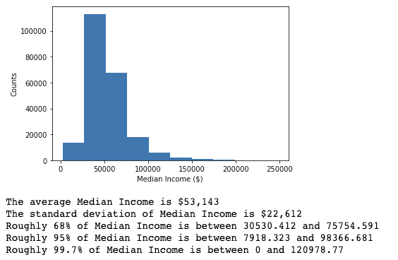

1. **What are the most common procedures performed by hospitals across the US between 2011 and 2017? Which 5 of these should we choose to analyze?**

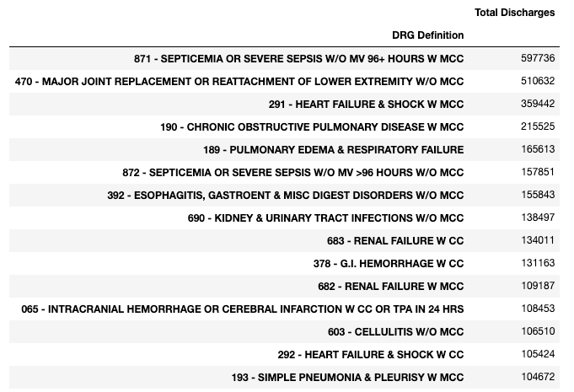

**Of the above 15 most common procedures, we chose to analyze the following 5:**

470 - MAJOR JOINT REPLACEMENT OR REATTACHMENT OF LOWER EXTREMITY W/O MCC,

871 - SEPTICEMIA OR SEVERE SEPSIS W/O MV 96+ HOURS W MCC,

392 - ESOPHAGITIS, GASTROENT & MISC DIGEST DISORDERS W/O MCC,

690 - KIDNEY & URINARY TRACT INFECTIONS W/O MCC,

194 - SIMPLE PNEUMONIA & PLEURISY W CC

1. **What does the variability of the costs of the 5 procedures chosen look like across the US?**

We looked at a) Histograms and b) Boxplots of average procedure costs for each of the five procedures. Below are an example of each of the distribution of the average costs across the US for Major Joint Replacement / Reattachment of Lower Extremity. In general, there seemed to be many outliers for the amounts charged for each procedure but with a large clustering around the median.

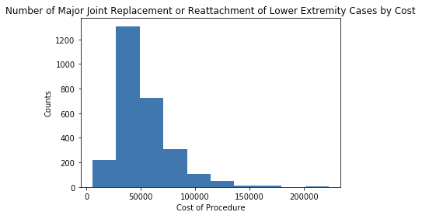

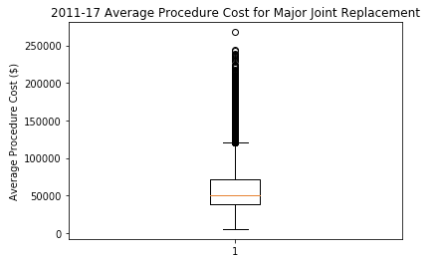

1. **Is the average of any given year’s hospital charges significantly different from the average hospital charges across all years?**

To answer the above, we performed a T-Test on the 2011 average charges for Major Joint Replacements against average charged for the same procedure across all years. The results showed that the amounts charged in 2011 did not vary significantly from the amounts charged across all 7 years for the same procedure.

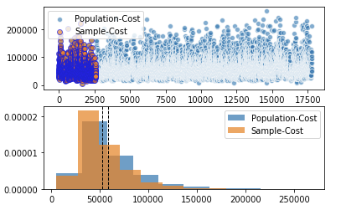

Ttest_indResult(statistic=11.689469833374295, pvalue=5.046905234523456e-31)

1. **Is there a correlation between average hospital charges for procedures and regional median income?**

We looked at scatterplots and performed a linear regression between median income and average procedure costs for each of the 5 procedures across all 7 years combined across the US.

**Our findings show that there exists no correlation between average hospital charges for procedures and regional median income.**

All r-values of the linear regression analysis between average hospital charges for procedures and regional median income were less than 0.05.

